You!
Lesson Title: | How will you be part of Colorado Springs history?
Grade Level(s): | K-12
Duration: | Varies based on ability

Description: | This lesson, focusing on a student’s role in the history of their community, can be a post fieldtrip lesson or a stand-alone classroom lesson.
Theme(s): | community
Skill(s): | compare and contrast

CSAS Standards: | ELA and Geography standards as selected by teacher
National Standards: | National Geography Standards  1. How to use maps and other geographic representations, geospatial technologies, and spatial thinking to understand and communicate information  9. The characteristics, distribution, and migration of human populations on Earth's surface  12. The processes, patterns, and functions of human settlement
Historical Connections: | Analyzing how someone will fit into the history of his or her community.

How will you be a part of Colorado Springs history?
Stage 1-Desired Results
Understanding(s):  Students will understand that . . .  - they are an important part of their communities history. | Essential Question(s):  Why is someone important in history?  Who is part of history?
Purpose:  Students will know . . .  - their place in their community’s history | Objectives:  Students will be able to . . .  - Add their stories to the history of Colorado Springs

Stage 2-Assessment Evidence
Performance Task(s):  - Students will write their story using Colorado Springs landmarks, number of landmarks dependent on age.  - Students will select a landmark to add to the “Y” portal through “Story of Us” | Other Evidence:  Observation during

Stage 3- Learning Plan
Setting:
General education classroom with 1 to 1 lap top availability and wireless access.
Materials/Technology Resources:
- Y is for “You” worksheet
- large print outs of maps of Colorado Springs (optional)
- cspmstoryofus.com
Current Colorado Springs Street Map
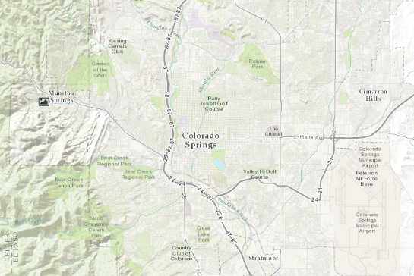 | Guiding Questions for map resource  - What date does the notch between the years 1865 and 1976 represent?  - From 1900 to 1905, what do you notice about the picture icons? Why did this happen?  - From 1945 to 1950, what do you notice about the picture icons? Why did this happen?  - In 1940, why do the trolley lines disappear?  - In 1875 and then in 1890, what do you notice about the picture icons? Why did this happen?

Learning Activities:
Teacher note: All learning activities are written with a 4-5 grader in mind. Activities can be done together for younger students and more independently for older students.

Session One:
- Visit the cspmstoryofus.com webpage and select “You” under the letter Y.
- On the bottom of your screen you will see a timeline. First, select the year 1875.
- You will notice that picture icons appear on the map.
- Select the picture icon by itself to the right of the clustered icons. The left picture is of Early Houses looking SW and it was taken in 1873. The right picture is present day in the same location.
- Provide time for your students to explore the other picture icons on the 1875 map.
- You will notice as you select each notch on the timeline different picture icons will appear. Spend some time looking through the picture icons from each notch. Be looking for a picture icon that you find really interesting to share with the class and write down the name of the picture and its location on the timeline. Students can work in groups or individually.
- Have students share out the pictures they found.

Session Two:
- Visit the cspmstoryofus.com webpage and select one of the following letters B, E, G, J, K, L, R, T, or V. Each of these letters represents a person from Colorado Springs history.
- Once you have clicked on the letter you will notice that there is an orange flag and numbered black circles. Click on each of these to discover places in Colorado Springs that were important to the person you choose to read about. Be ready to share out to the class a bit about the person you are reading about.
- Now go back and select the “You” again under the letter Y.
- Select the 2015 notch on the map. What do they notice?
- The museum is interested in adding to their map with our pictures!
- When you looked at your person today, you may have noticed that all the places on the map represented places that were important to their story. What places in Colorado Springs are important to your story?
- Using the current Colorado Springs road map select 2-3 places that help tell your Colorado Springs story. For each place you will need the reason why it is important and a current picture of the place.
- Now pick one of the places and fill out the Y is for “you” worksheet. Using your worksheet, you will upload your place to the “You” database using the instructions on the Colorado Springs Pioneer Museum website.
Teacher note: Students can also upload audio files of them talking about the place and pictures of artifacts, such as a movie ticket stub or program. Artifacts can also be family heirlooms.

is for “You”!
Name _______________________________________
Contact Info __________________________________
Location _____________________________________
Reason place/item is important ___________________ _______________________________________________________________________________________________________________________________________

picture or picture of artifact

If an audio recording, attach script.

