V is for Vallejos Restaurant

Lesson Title: | Exploring the Hispanic Influence in the Pikes Peak Region and Beyond
Grade Level(s): | Grades Nine through Twelve
Duration: | 1 to 2 class periods (50 minutes each)

Description: | This lesson is intended to be used before or after a visit to the Story of Us exhibit.
Theme(s): | Migration, ethnicity, urbanization
Skill(s): | Close reading, map analysis, synthesizing information

CSAS Standards: | History 1a, 1b, 1c, 2j  Geography 1a, 1c, 1d, 3a, 3f
National Standards: | Common Core State Standards English Language Arts - Literacy.RH.9-10.1 and 10.7
Historical Connections: | Local and historic connections to national events

“V” is for Vallejos/ the Hispanic Influence in the Pikes Peak Region

Introduction

In 2015, a Top 100 list (click here for article from the Colorado Springs Independent) was published that listed the most diverse cities in the United States. It might be surprising, but Colorado Springs came in at number 22 (Denver was number 67). However, once you start to look at the geography and history of the Pikes Peak region, one begins to see that this diversity has been present all along. Through the following activities you will examine one Colorado Springs family’s story, as well as some maps and other geographic tools, to begin to explore the Hispanic Influence in the Pikes Peak Region from 1950- present.

***Notes for the teacher***
- This lesson is designed assuming students have some background knowledge about the early Spanish explorers in the American West, as well as
- A computer/tablet with internet access is required for this lesson. Teachers may also choose to create a worksheet (paper or electronic) based on the questions below.
- Step 1, 2, and 3 questions can be answered in a formal written response, or can be used by the teacher to facilitate a group discussion, or they can be used among students in pairs/small groups. Step 4 should be completed in a written format.

Step 1

Go to http://cspmstoryofus.com/ and scroll down to click on “V”. Then click on “Vallejos Restaurant”. On the left menu, click “Read More” under the text starting with “Vallejo Family Restaurant”. Once you have finished reading, answer the questions that follow. Note that some of these topics are not directly mentioned in the article, so you will need to tap into some prior knowledge and your own critical analysis.
- How did the Vallejo family come to settle in Colorado Springs?
- What challenges did the family face once they settled in Colorado Springs (keep in mind they settled here in the 1950s).
- What is the legacy of the Vallejo Family and their restaurant?
- So what? How does their family story speak to the bigger story of immigrants and ethnic diversity in the Pikes Peak Region? How about in the United States?

Step 2

Click the “X” to exit the Vallejo Restaurant article and return to the map of Colorado Springs (make sure there are no historic maps activated, and that you are on street view, not satellite view). Center the orange flag “main location” map on the center. Now, take a minute or two and just observe the street names in Colorado Springs. Answer the questions that follow.
- What initial observations do you have when looking at the map?
- How would you describe the street names that are northwest of the orange flag?
- How would you describe the street names that are northeast of the orange flag?
- How would you describe the street names that are south (both west and east) of the orange flag?
- What connections can you make between the street names that are in the south and the Vallejo family story? Why do you make these connections?

Step 3

Complete the Activity 4 Level Map Analysis: “V” is for Vallejos (attached)

Step 4 (finally!)

Write a short constructed response (SCR) to the following prompt. Please be sure to cite any evidence you used from any of the information from steps 1 through 3. Be sure to provide your own interpretation and analysis.

Prompt: What is the Hispanic influence in the Pikes Peak Region from 1950 to the present? How does this story compare to the national story of Hispanics in the United States?

***Suggested additional activities***

- Have students create their own map on ARCGIS using the various layers to demonstrate the impact of Hispanics in the Pikes Peak Region and in the United States. (Hispanic population centers, Spanish speaking majorities, Catholics, etc…)

- Have students find resources similar to those used in the lesson provided to discuss the impact of other ethnicities, races, religions, etc… in the Pikes Peak Region, United States, anywhere!

Name______________________________________________ Period _____________
“V” is for Vallejo 4-LEVEL MAP ANALYSIS
Map taken from “Where the Races Live in Colorado Springs” 2015
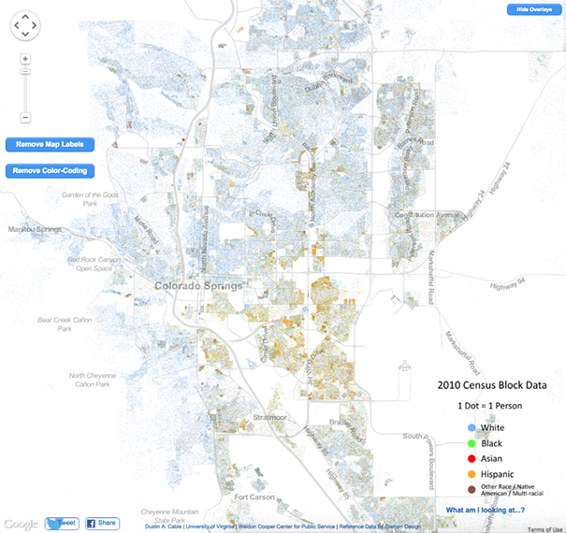
Level 1: WHAT
Level 2: WHERE
Level 3: WHY THERE
Level 4: SO WHAT
“V” is for Vallejo 4-LEVEL MAP ANALYSIS
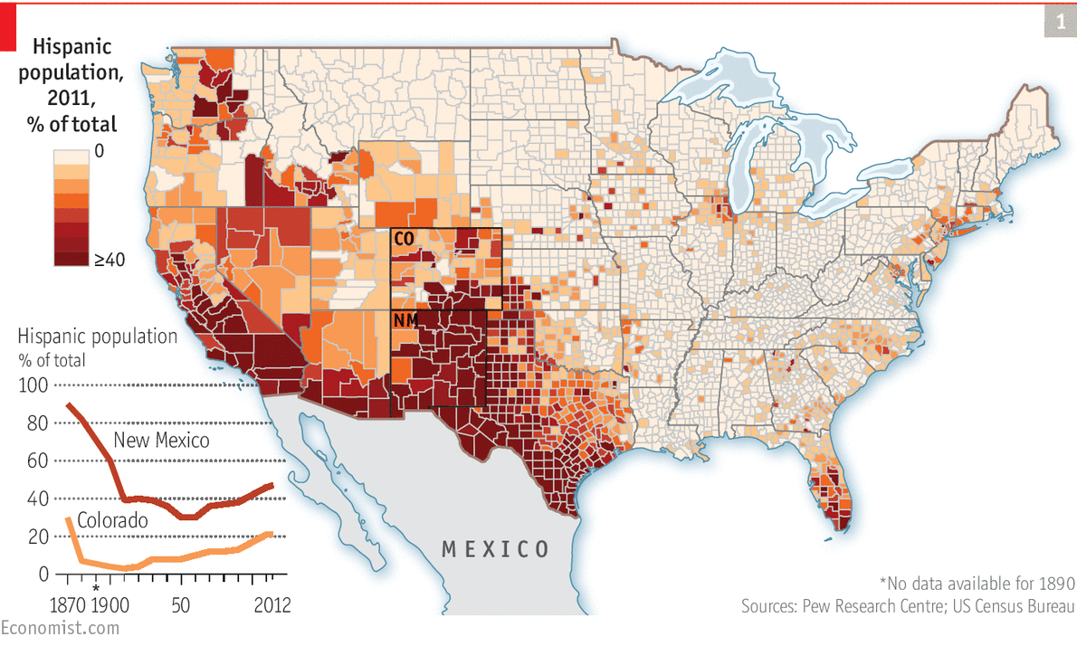

Level 1: WHAT
Level 2: WHERE
Level 3: WHY THERE
Level 4: SO WHAT

