Q for Quarry

Lesson Title: | How and Why in the Red Rocks Open Space
Grade Level(s): | Grades 9 through 12
Duration: | 1 to 2 class periods (50 Minute sessions), including discussion time
Description: | Classroom lesson
Theme(s): | Geology, local history, Map literacy
Skill(s): | Close reading, map analysis, Information Synthesis.

CSAS Standards: | Science standards: 3.1.abd  3.6.abcd
National Standards: | Common Core: CCSS.ELA-LITERACY.RST.9-10.1  CCSS.ELA-LITERACY.RST.9-10.4  CCSS.ELA-LITERACY.RST.11-12.9
Historical Connections: | Local historical connection to local geology
Websites
Main Website:
Website 1

Science | History | Photos
Website 2 | Website 5 | Website 9
Website 3 | Website 6 | Website 10
Website 4 | Website 7 | Website 11
 | Website 8 | Website 12

Standards: Colorado Science Standards
3.1: The history of the universe, solar system and Earth can be inferred from evidence left from past events
- Develop, communicate, and justify an evidence-based scientific explanation addressing questions about Earth’s history (DOK 1-3)
- Analyze and interpret data regarding Earth’s history using direct and indirect evidence (DOK 1-2)
d. Seek, evaluate, and use a variety of specialized resources available from libraries, the Internet, and the community to find scientific information on Earth’s history (DOK 1-2)
3.6. The interaction of Earth's surface with water, air, gravity, and biological activity causes physical and chemical changes
- Develop, communicate, and justify an evidence-based scientific explanation addressing questions regarding the interaction of Earth’s surface with water, air, gravity, and biological activity (DOK 1-3)
- Analyze and interpret data, maps, and models concerning the direct and indirect evidence produced by physical and chemical changes that water, air, gravity, and biological activity create (DOK 1-3)
- Evaluate negative and positive consequences of physical and chemical changes on the geosphere (DOK 2-3)
- Use remote sensing and geographic information systems (GIS) data to interpret landforms and landform impact on human activity (DOK 1-2)

Big Questions
How did the Lyons and Fountain formations form?
How and why did people quarry the area?
What has changed - compare historical maps to current maps?

Part 1: Getting to know you
- Thinking back to the rock cycle what type of rock is made up of other types of rocks?
- When the particles are cemented together what are the different basic types of cement used and what are the general characteristics of these?

Click on Website 1 (see chart above), then click “read more”, and click orange flag photos 2-9, Website 2, and Website 4.
- Give a summary of how the local area has changed leading up to the formation of the Canyon. Be specific.
- What is the name given to the land feature prominent in this area? The base of the foothills is a clue.
- How has human impact changed and modified the landscape?
- Looking at the weathering/erosion of the area, how would humans be classified? Why?

Part 2: Mapping it up
Use Website 1 with the following map filters: 1916 geologic map, 1893 USGS Topo Map, orange flag picture 1.

Website 3 and Website 12: Compare the 1916 geologic map to the current geologic map.
- Do you notice any differences?

Compare the 1893 Topo map to photo 1.
- What do you notice between the two?
- What direction is the photographer facing?
- Mark on the map below where you think the photographer is standing.
- Looking at the topo map, where are the hog backs located?
- How can you tell?
- Where is the quarry located?

Using website 12, where is this photo sitting roughly on the topomap?
- What can we see here that we can’t see on the maps? Mark on the map below.
- Why is data like this important?
- Use the data gathered above to identify locations, rock types, and important information on the map below.

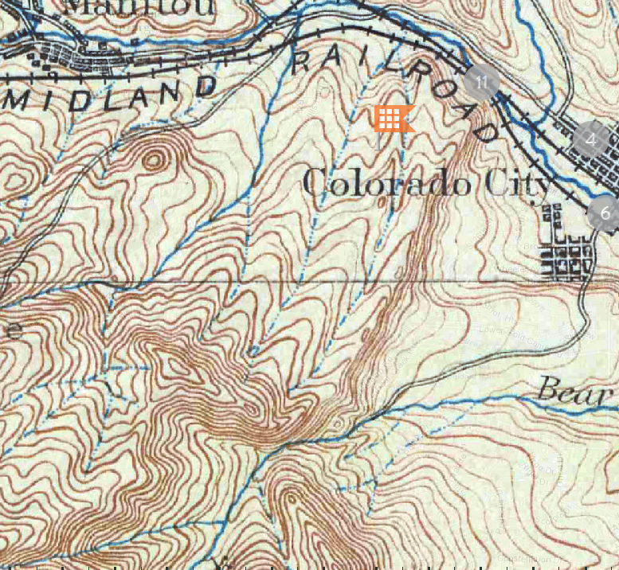
MAP TITLE AND LINK

Part 3: All around the town:
Use Website 5, Website 6, Website 7, and Website 11

- Using the stone from the stone Kenmuir Quarry locally throughout Manitou, Colorado Springs, and Denver led to the massive amounts of the stone being cut and moved. But why?
- Looking at Website 11. Shoshone Spring is a spring in Manitou. It has had three different coverings with the last being Stone from the quarry. It was built in the 1890’s and is still standing. What does that tell us about the rock?
- Looking at the website 7, examine the Creswell mansion and the Croke-Patterson-Cambell Mansion. What similarities do you see in each of these?
- What does each have that your house does not have?
- Thinking back to the weathering page, what are houses like this susceptible to? Why do you think these have lasted as long as they have?

Part 4: The Exit Ticket
Choose one of the following questions to answer using the information gathered and the inferences you have made.

- How has technological advancements changed the way we have viewed a specific area i.e. the Red Rocks Open Space. Be specific and use examples.
- Thinking of all that you have learned here in what ways do you think the local geology has shaped the Colorado Springs / Manitou Springs area? How have Humans impacted this same area?

Website Links
Website 1 http://www.cspmstoryofus.com/
Website 2 http://redrockcanyonopenspace.org/education/geology/
Website 3 http://redrockcanyonopenspace.org/education/geology/geographic-map/
Website 4 http://redrockcanyonopenspace.org/education/geology/rock-weathering/
Website 5 http://redrockcanyonopenspace.org/education/history/bott-and-langmeyer-building-stone/
Website 6 http://redrockcanyonopenspace.org/education/history/the-red-rock-quarries/
Website 7 http://redrockcanyonopenspace.org/education/history/red-rock-canyon-stone-in-denvers-historic-buildings/
Website 8 http://redrockcanyonopenspace.org/education/history/mining-in-and-around-red-rock-canyon/
Website 9 http://redrockcanyonopenspace.org/wp-content/gallery/redrockcanyon/img_0960.jpg
Website10 http://redrockcanyonopenspace.org/wp-content/gallery/redrockcanyon/dsc_0011.jpg
Website 11 http://static.panoramio.com/photos/large/26233904.jpg
Website 12 https://www.google.com/maps/@38.8437538,-104.8832321,3a,75y,263.01h,113.25t/data=!3m8!1e1!3m6!1s-BQ2FMC5GLKY%2FV1cwdpeWzdI%2FAAAAAAABk28%2FAWZco8Hj2CYeEGKoOkUw9IzIDgMeW_KzgCJkC!2e4!3e11!6s%2F%2Flh6.googleusercontent.com%2F-BQ2FMC5GLKY%2FV1cwdpeWzdI%2FAAAAAAABk28%2FAWZco8Hj2CYeEGKoOkUw9IzIDgMeW_KzgCJkC%2Fw203-h100-k-no-pi-0-ya126.356026-ro-0-fo100%2F!7i7680!8i3072?hl=en

