P is for Poor Farm

Lesson Title: | Taking Care of Us
Grade Level(s): | Fourth and Fifth Grades
Duration: | Six class days

Description: | How has the Colorado Springs community taken care of its needy citizens in the past and in the present?
Theme(s): | By taking care of our community, we take care of all of us
Skill(s): | Primary Source Analysis, Cause and Effect, Map Skills, Critical Thinking, Problem Solving, Student Collaboration and Presentation, Writing

CSAS Standards: | Develop an understanding of how people view, construct, and interpret history (History 1.1)  Examine places and regions and the connections among them (Geography 2.2)
National Standards: | National Geography Standards  How to apply geography to interpret the past (Standard 17)  How to apply geography to interpret the present and plan for the future (Standard 18)
Historical Connections: | ???

Content Area | History/Geography
Historic Site: | Present Day Bear Creek Park and Charmaine Nymann Community Gardens, Pauper’s Cemetery
Background Information | In August of 1880, the El Paso County Commissioners purchased a small cottage on El Paso Street as a place to take care of the sick and poor in Colorado Springs. At the time, there were few social programs available to help people who were too sick to work and/or too poor to pay their bills. This Poor Farm was expanded twice by 1886. Due to the building being cramped and overcrowded, the El Paso County Commissioner proposed demolishing the building and rebuilding a larger “Country Home.” Unfortunately, the neighbors protested this new expansion not wanted more of the poor in town and, consequently, the Board of Commissioners decided to find another location farther outside Colorado Springs. They purchased 525 acres of the Liebig Ranch, which was southwest of downtown and located on the land that is present day Bear Creek Park. The move was made to the new building on the new property in January 1889, but shortly thereafter it burned to the ground. By October 1889, yet another fire-proofed building was completed. The Colorado Springs Poor Farm continued to be in operation until 1984 when it was demolished, and is now the current site of Bear Creek Park. The Poor Farm model was borrowed from the British and used in the 18th and 19th Centuries here in the United States. The Colorado Springs Poor Farm was the second to the last poor farm to close in the country.
Key Vocabulary Terms | Pauper, alms, almshouses, Poor Farms, Poor Houses, Board of County Commissioners
How and when to use this lesson | 1. Day1 Activity: Pre-Story of Us Exhibit Museum Visit or Online Version of Exhibit  2. During Visit of Story of Us Exhibit; fill out primary source analysis handout during visit at display  3. Day 2 through 5: Post-Story of Us Exhibit visit
DAY 1: Pre-Story of Us (SOU) Exhibit visit: Classroom Lesson

*Activity: Divide students into small groups to complete a T-chart with the headings: Early Colorado Springs (1800-1980) and Present Colorado Springs (1985-present). Have students list problems people may have faced/do face in each column, taking into account the changes that occurred in the area at the two time periods (growth, railroads, gold, tourism). As a whole group, discuss findings and look at common themes.
*Pose the Essential Question to students and focus on care of the needy in the community. Go over vocabulary terms for background knowledge. Have these posted on board or chart for easy reference.
Colorado Poor Laws | Activity:  - Students will examine the primary source document by using their skills to observe, reflect, and pose questions about the Colorado Poor Laws of 1904. This document should help students to understand the state definition of who was considered to be poor during this time period of the early 1900’s. This will help set the foundational understanding of why poor farms came into existence.  - Pass out the Analyzing Primary Sources documents for students to observe, reflect, and pose questions about the document. If you have not previously used this analysis sheet with your students, do this as a “we do” together modeling how to observe, reflect, and question as you fill in the handout together.  http://www.loc.gov/teachers/usingprimarysources/resources/Analyzing_Primary_Sources.pdf  http://www.loc.gov/teachers/primary-source-analysis-tool/  https://geoalliance.asu.edu/geolens  Directions to students:  - Using the Primary Source Analysis Tool, what do you see (observe), think you know (reflect), and what questions do you have about Colorado Poor Laws in 1904? Record on analysis handout.  - Have students collaborate with another group to share out their findings or share out as a whole group, recording their information on chart paper.  - Discuss with students their thoughts on this definition. Is it a fair definition? Does it work as a definition for today’s poor? Compare to a current definition of poverty.  Ending Activity  - Have students quickly sketch what they think a Poor Farm would have looked like. They will have to account for WHY they included certain features. Save sketch for later.
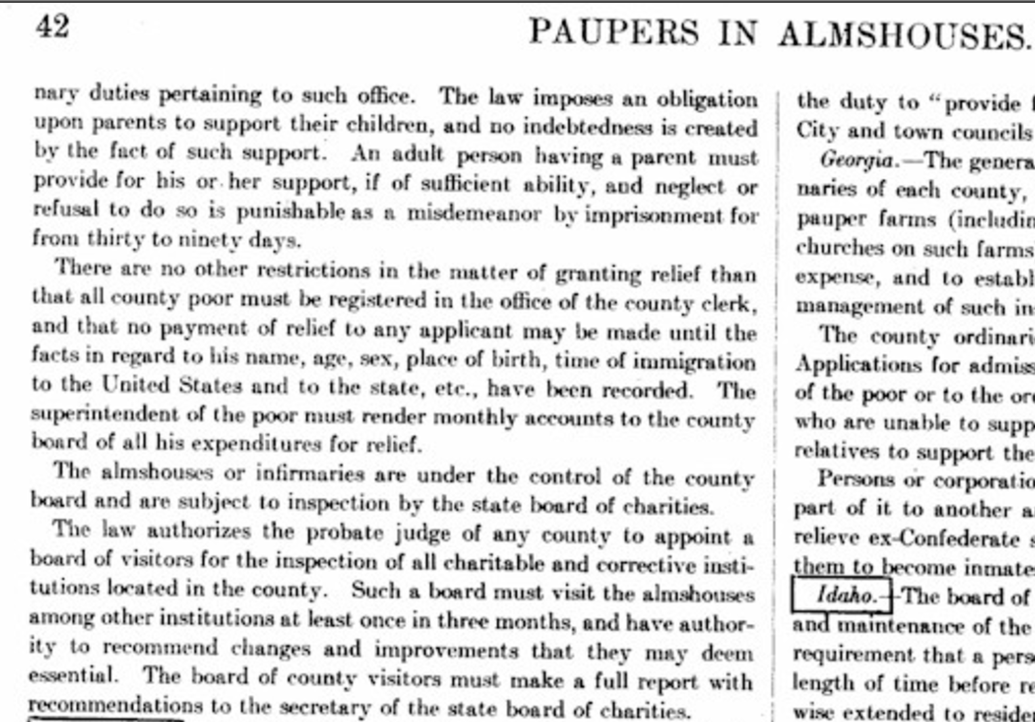

http://www.poorhousestory.com/LegalSummary42.htm
DAY 2: Visit Story of Us Exhibit or Virtual of Exhibit Online : Colorado Springs Pioneers Museum or Internet

Recap information learned so far about the Colorado Springs Poor Laws from Day 1 Activity. Remind students what the Essential Question is: How has Colorado Springs taken care of its needy citizens in the past and in the present day?
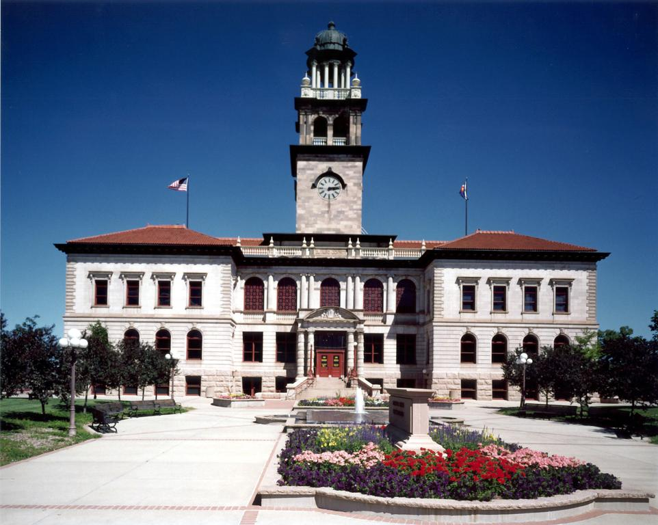  Colorado Springs Pioneers Museum  215 S. Tejon St.  Colorado Springs, CO 80903  www.CSPM.org  Contact: Meg Poole  mpoole@springsgov.com  719-385-5631 | Activity:  - Visit the Pioneers Museum SOU exhibit with emphasis on P is for Poor Farm and other exhibits in the museum. (I highly suggest an in-person visit as the exhibit has a display that allows students to overlay old maps over current maps and see the geographical and historical changes to the area.)  - Please note: If you are planning a trip to the Colorado Springs Pioneers Museum to have your students experience the SOU exhibit in person, please make sure to contact Meg Poole at the museum at least 2 weeks before your intended visit. This helps to ensure that someone is available to greet you and to help you navigate the museum.  Contact info: Meg Poole, mpoole@springsgov.com and/or 719-385-5631  - Before leaving: Make sure students have a pencil, clipboard or notebook, and copies of the Primary Source Analysis Tool handout to observe, reflect, and record questions about the “P is for Poor Farm” display. You may wish to have the teacher copy of this handout with facilitating questions to ask during the SOU visit if students need help filling out the document.  - http://www.loc.gov/teachers/primary-source-analysis-tool/  http://www.loc.gov/teachers/usingprimarysources/resources/Analyzing_Maps.pdf  Visit the Pioneer’s Museum SOU exhibit online:  - Students will need computers. They can work as partners or individually.  - Log on to the SOU exhibit site: http://cspmstoryofus.com/. Students will choose the letter “P” and click on “Poor Farm”. Using the Primary Source Analysis Tool, students will gather information about the Colorado Springs Poor Farm, manipulate the interactive map, access the primary source documents embedded, and record research on their sheet

DAY 3: Post-Story of Us Exhibit visit: Classroom Lesson

Recap information learned so far about the Colorado Springs Poor Farm from Days 1 & 2 Activities and from Exhibit visit. Remind students what the Essential Question is: How has Colorado Springs taken care of its needy citizens in the past and in the present day?
Colorado Springs Poor Farm Maps | Activity:  - Pass out color copies of the two maps of the Poor Farm to groups along with magnifying glasses or window frame/lens tool (notecards laminated with a square hole cut out in the middle so that students can use to focus on one area of the map at a time. It will look like a window frame.) Also, pass out the primary source analysis tool. http://www.loc.gov/teachers/primary-source-analysis-tool/  - Using the Analyzing Maps tool, put any of the questions you seem appropriate for students to discuss/use on board that will help them fill out the observe, reflect, and question. http://www.loc.gov/teachers/usingprimarysources/resources/Analyzing_Maps.pdf  Directions to students:  - Using the Primary Source Analysis Tool for both maps, what do you see (observe), think you know (reflect), and what questions do you have? Record on analysis handout. Refer to teacher questions from Analyzing Map document from Library of Congress to analyze map deeper. Compare maps to each other.  - Investigative Inquiry: Discuss findings as whole group from student map analysis. Go over their questions. Ask, “Why do you think there are two maps for the Poor House?” “How far from downtown Colorado Springs is the 2nd Poor Farm?” (Compare to larger Colorado Springs map of area). “Why do you think one poor farm is in town and one out?” Discuss clues on map that help answer questions. Fill in background information for students regarding move, purchase of land, fire, rebuilding, etc. Discuss the social implications of separating those different from us.
1st El Paso County Poor Farm Map:
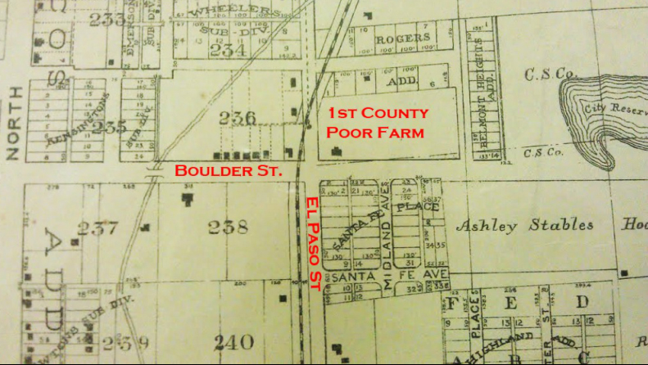
http://radiocoloradocollege.org/wp-content/uploads/2012/02/FirstPoorFarm.jpg

2nd El Paso County Poor Farm Map:
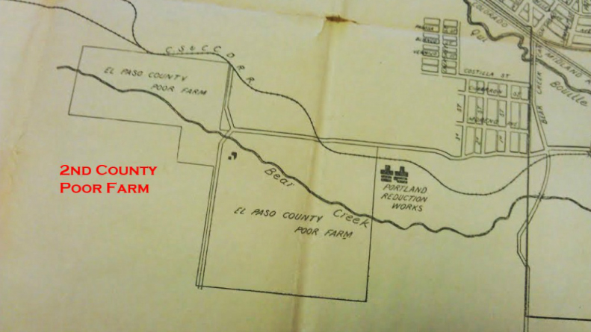
http://radiocoloradocollege.org/wp-content/uploads/2012/02/SecondPoorFarm.jpg

DAY 4: Post-Story of Us Exhibit visit: Classroom Lesson

Recap information learned so far about the Colorado Springs Poor Farm from Day 1-3 Activities and from Exhibit visit. Remind students what the Essential Question is: How has Colorado Springs taken care of its needy in the past and in the present day?
Colorado Springs Poor Farm | Activity:  - Have students get out their sketch of a poor farm. Share with a partner.  - Pass out color copies of the pictures of the Colorado Springs Poor Farm, primary source analysis tool, and student magnifying glasses or window frame/lens notecard tool. http://www.loc.gov/teachers/primary-source-analysis-tool/  - Using the Analyzing Photographs and Prints tool, put up on the board any of the questions you deem appropriate for students to discuss or use for investigation that will help them fill out the observe, reflect, and question tool. http://www.loc.gov/teachers/usingprimarysources/resources/Analyzing_Photographs_and_Prints.pdf  - Have partners complete a Venn Diagram: What I thought a Poor Farm would be/look like, What a Poor Farm actually looked like, What things are similar.  Directions to students:  - Using the Primary Source Analysis Tool for the picture, what do you see (observe), think you know (reflect), and what questions do you have? Record on analysis handout. Refer to teacher questions from Analyzing Photographs and Prints document from Library of Congress to analyze photo deeper. Students compare this picture of the Colorado Springs Poor Farm to their sketch of what they thought a poor farm would look like. Discuss similarities/differences. Give background info that the same architect that built the Pioneers Museum also built the Poor Farm. Why?  - Background Knowledge: Have students read online the article about “History of 19th Century Poor Houses”, highlighting important information: http://www.poorhousestory.com/history.htm.
Poor Farm 1900s
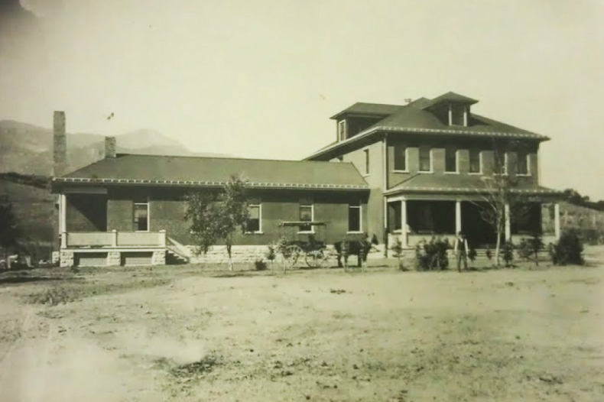
El Paso County Poor Farm, ca. early 1900's, photographer unknown. Courtesy of the Colorado Springs Pioneers Museum.

http://radiocoloradocollege.org/wp-content/uploads/2012/02/PoorFarm1900s.jpg

DAY 5: Post-Story of Us Exhibit visit: Classroom Lesson
Recap information learned so far about the Colorado Springs Poor Farm from Day 1-4 Activities and from Exhibit visit. Remind students what the Essential Question is: How has Colorado Springs taken care of its needy in the past and in the present day? Today’s lesson will add more historical background about the Poor Farm.
Historic Fountain, Colorado Website:  Poor Farm | Activity:  - Students will need computers to navigate website, and primary source analysis tool to observe, reflect, and question. http://fountaincolorado.blogspot.com/2011/06/county-poor-farm.html http://www.loc.gov/teachers/primary-source-analysis-tool/  http://www.loc.gov/teachers/usingprimarysources/resources/Analyzing_Photographs_and_Prints.pdf  - Group students into small groups and assign one of the pictures to each group. More than one group will have the same picture. Pass out analysis tool and post facilitating questions from Analyzing Photographs and Prints doc around the classroom or project on screen for reference for students to answer.  Directions to students:  - Using the Primary Source Analysis Tool for the picture, what do you see (observe), think you know (reflect), and what questions do you have? Record on analysis handout.  - Have groups present to the whole group their information (in chronological order so as to piece story together) using the 5W’s format.  - Discuss article about books found during demolition of building.  - Have students go to the Pauper’s Cemetery website and gather Who, What, Why, When onto sticky notes and post under 5W’s around the room. Discuss info.  *Have students go to Google Earth and bring up current map of Bear Creek Park to compare to older maps we looked at on Day 3.  ASSIGNMENT: Compose a 1-page diary entry of life on the Poor Farm. Include
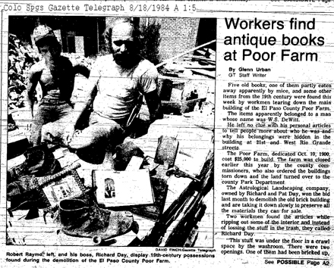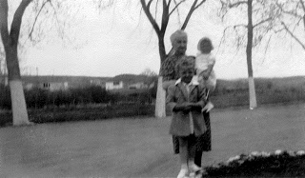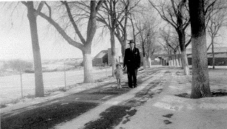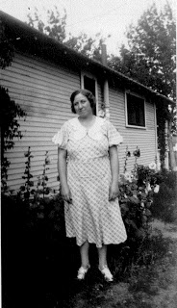
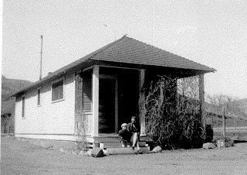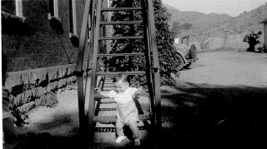
http://fountaincolorado.blogspot.com/2011/06/county-poor-farm.html
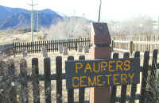
http://www.colorado-cemeteries.com/pauper-cemetery.html

DAY 6: Post-Story of Us Exhibit visit: Classroom Lesson and Assessment

Recap information learned so far about the Colorado Springs Poor Farm from Day 1-5 Activities and from Exhibit visit. Remind students what the Essential Question is: How has Colorado Springs taken care of its needy in the past and in the present day? Transition to the present day ways that Colorado Springs takes care of their needy today.
Colorado Springs Present Day:  How we help the needy today | Activity:  - Students will need computers to navigate websites and work with a partner.  - Share out, creating a chart listing results of research to make one common document.  Directions to students:  - Students research online Colorado Springs organizations and how they help the needy. Have them take Cornell Notes into a Word document on their U-drive, Google Drive, etc. with info they find.  - Create a compiled list of the research together onto chart paper. Add to list if students missed any organizations.  - Compare Colorado Springs help of the needy, past and present, and how the community tried to meet their needs. Use a Venn Diagram graphic organizer to organize info.  - ASSIGNMENT: Students write an opinion piece about whether Colorado Springs did a better job in the past or in the future taking care of their needy.  - Community ACTION Step…Invite an organization/charity representative to come talk to class about their organization, answer questions (students compile before visit), and find out how their class could help the community through (e.g. sock drive, serve meals, stock up food bank).
Colorado Springs Social Support Organizations:
- Care and Share Food Bank
- Ecumenical Social Ministries
- Family Promise
- Marian House
- Partners in Housing
- PPACG Area Agency on Aging
- Pikes Peak Community Action Agency
- Salvation Arm
- Seeds Café
- Springs Rescue Mission
- Urban Peak
- Westside Cares
- Church outreach ministries
- Military base support programs
- Government-funded support programs

Assessment Question:
How has the Colorado Springs community taken care of its needy citizens in the past and in the present?
Assess:
- Primary Source Analysis Worksheets
- Discussion/Group Work Expectations: Teacher Created Rubrics (critical thinking skills, group/individual presentation)
- Writing Assignments: Diary and Opinion essay
- Venn Diagrams
- Cornell Notes from group work/research
Action Steps w/organization: Questions for presenter/steps to help community
Reflection on lessons/student interactions
What went well?
What would I change; add/delete?

