Terrain navigation and feature interpretation in Google Earth
Dr. Paddington Hodza, phodza@uccs.edu
University of Colorado at Colorado Springs

There is a wealth of information to be found in Google Earth mainly from embedded satellite and aerial imagery, street data and 3D terrain models. Users can discover, for example, how people around the world are modifying natural environments into settlements, agricultural fields and mining sites. In addition, users can bring their own data (e.g. demographic, environmental, etc.) into Google Earth. They can explore, analyze and interpret this data and solve geographic problems.

In this exercise, you will navigate the Google Earth virtual globe, raise questions about different situations that you will find, and interpret terrain features. The purpose of the exercise is to demonstrate how to implement Geography Standard 5 in the classroom. Geography Standard 5 requires that students understand the effects of interactions between human and physical systems and the changes in meaning, use, distribution, and importance of resources.

- Start Google Earth.

- Measure geographic coordinates in Google Earth.

In the Search panel, specify that you want to fly to “Victoria Falls, Africa.” Click on some of the point markers to display pictures uploaded by Google Earth users.

In which country or countries is the Victoria Falls? __________________________________
What evidence shows that there is white water rafting around the Victoria Falls? _____________________________________________________________________________________________
Give the geographic coordinates of this evidence:
Latitude_____________________ Longitude ______________________

- Measure elevation and distance in Google Earth.

In the Search panel, specify that you want to fly to “Pikes Peak.” The displayed image can be draped onto a 3D terrain surface by going into the Layers panel and checking the box to the left of Terrain. Change the viewing perspective to explore the terrain in 3D.

What is the elevation of the point on Pikes Peak marked by balloon marker ‘A’? __________
Is this the highest point on Pikes Peak? Use an independent source to verify your answer ___________________________________________________________________________________
_____________________________________________________________________________________________
When do you think the satellite image of Pikes Peak was taken? What evidence supports your answer? _____________________________________________________________________________________________
_____________________________________________________________________________________________
What is the distance between balloon markers ‘A’ and ‘B’?
_________________________ miles ___________________________ kilometers

- Examine detail of Google Earth data.

Google Earth embeds satellite and aerial imagery at various resolutions. Image resolution refers to the amount of detail in an image and provides insight into the size of the smallest feature that can be identified from the image. For most areas, the resolution of Google Earth data is about 15m. In cities, data resolution can be much higher allowing users to explore neighborhoods at the street level at incredibly high detail.

Fly To “4310 Ridgelane Dr, Colorado Springs.”

How many houses are on Meadowview Ct, east of Ridgelane Dr? __________________
How many animals can you see? _______________________________________________________
How many backyard porches can you see? ____________________________________________

In the Layers panel, check the box to the left of Street View and uncheck the Terrain layer if checked. The Street View data gives you a ground level look at neighborhoods. Place your cursor on digital camera icons on Ridgelane Dr to display their address locations. Double click the camera on “4310 Ridgelane Dr”. Explore the 360 view of the street. Now double click on the next camera on and do the same street-level exploration.

What do you think about providing this level of street detail to the public? _____________________________________________________________________________________________
_____________________________________________________________________________________________
_____________________________________________________________________________________________

- Interpret human activity from satellite and aerial imagery.

Humans use the land in many different ways. These uses can be classified into rural, urban, forested and agricultural to name but a few, and are commonly known as landuses. Each landuse class can also have specific sub-classes such as residential and commercial for urban.

Fly To 38 04 8.42N, 81 58 30.44W

Make sure the Terrain layer is turned on. Double click on the helmet icons to display information about this site. (Note: You may have to zoom in a lot and explore around to get a better understanding of this site)

In which US state is this location? _____________________________________________________
What kind of commercial activity is taking place at this location? __________________
_____________________________________________________________________________________________
Using evidence at this location to support your answer, what do you think are the consequences of this human activity? ____________________________________________
_____________________________________________________________________________________________

- Compare landuse from different places.

In this exercise, you will compare landuse and imagery colors from two different locations. You can copy and paste the images from each scene into Microsoft Word for side-by-side comparison. To do this, go to Edit, choose Copy Image, and then paste image into Word. Note, you may have to zoom in and out a lot to get good images.

Navigate to 37 27 12.36N, 80 48 22.73W.
Is there any evidence of agricultural activity in this area? __________________________
What is the color of vegetation and water? ___________________________________________

Navigate to 40 06 25.28N, 105 51 11.79W.
Is there any evidence of agricultural activity in this area? __________________________
What is the color of vegetation and water? ___________________________________________
Are the colors the same as in the scene above? Why or why not? __________________
____________________________________________________________________________________________
What is the influence of topography on agriculture at these sites? _________________
____________________________________________________________________________________________
____________________________________________________________________________________________

- Fly to Powell, ND and zoom out a few times.

This site can provide the starting point of an interesting discussion on the US Public Land Survey System (PLSS). Can you see evidence of the township and range system? What are the dimensions of the rectangular sections (e.g red rectangle in Figure 1)? _________ miles

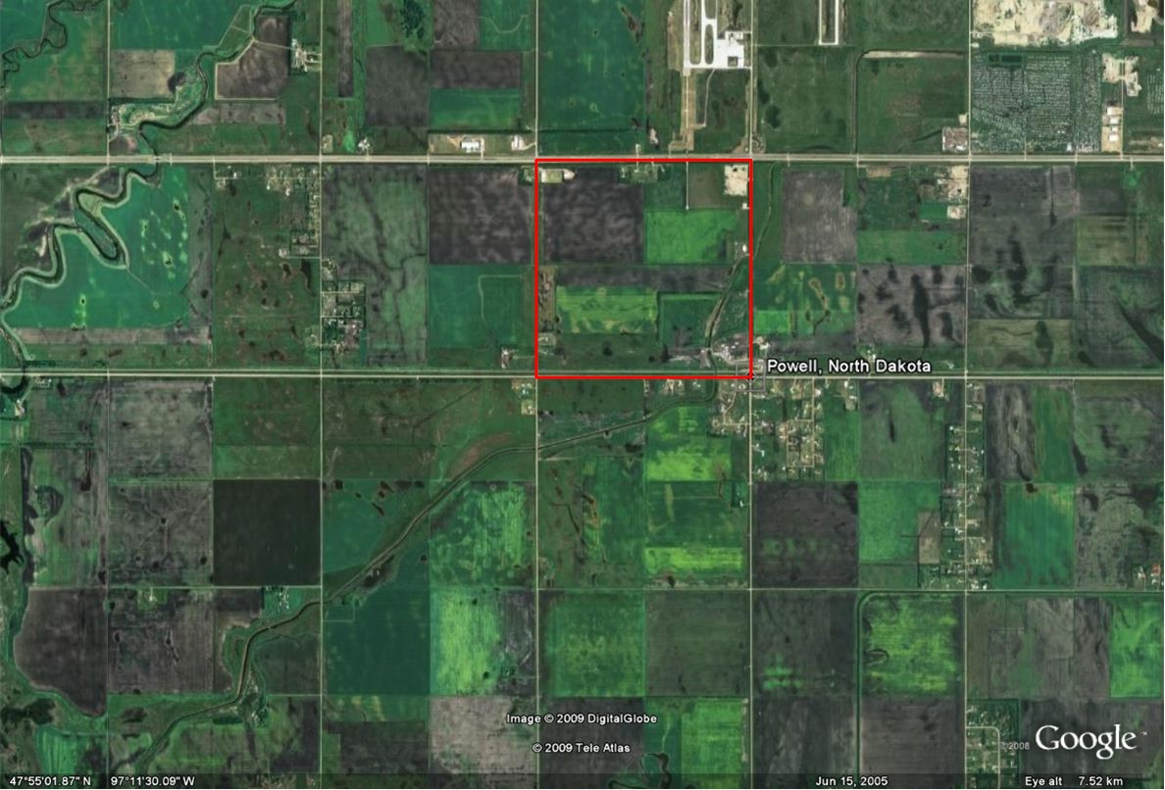
Figure 1: Powell, North Dakota (Source: Google Earth, 2009)

