Historic Maps

Lesson Title: | How has Colorado Springs changed?
Grade Level(s): | First through Third
Duration: | Two 40-minute sessions, time will vary based on the number of maps used

Description: | This lesson, using historic Colorado Springs maps, may be completed in the classroom or in the museum in small groups.
Theme(s): | Change over time
Skill(s): | Map skills, compare and contrast

CSAS Standards: | 3rd grade Geography: 1. Use various types of geographic tools to develop spatial thinking  2nd grade Geography: 1. Use geographic terms and tools to describe space and place  1st grade Geography: 1. Geographic tool such as maps and globes to represent places
National Standards: | National Geography Standards  1. How to use maps and other geographic representations, geospatial technologies, and spatial thinking to understand and communicate information  4. The physical and human characteristics of places  17. How to apply geography to interpret the past
Historical Connections: | Studying the growth of Colorado Springs from 1882 through the present.

Document Based Questions (DBQ)
Title / Content Area: | Historical Colorado Springs, Geography
Historic Site: | Colorado Springs
Developed by: | Marni Zabel
Grade Level: | Lower Elementary
Assessment Question: | How has Colorado Springs changed over time?
Contextual Paragraph | Founded in 1871, Colorado Springs has grown from the original boundaries to the large metropolitan and suburban area you see today. Over time roads have been added, names have been changed, buildings have been demolished, and Colorado Springs has expanded well beyond its original borders to incorporate Colorado City and the small mining town of Roswell. Using the maps featured in this DBQ, students will analyze how Colorado Springs has changed starting with an 1882 Colorado Springs map to the current street map and learning basic map skills at the same time.
Learning Plan
Session 1:
- Access the cspmstoryofus.com website, click on the H, and then the Historic Maps Link. Select the satellite view from the left side navigation bar.
- Looking at the map, lead the students in an oral discussion of the observe phase of analysis using the following suggested questions.
- What size and shape is the map?
- What do you see?
Use the questions below to help guide their observation if they are struggling.
- What streets do you see?
- What places do you see?
- What on the map looks strange?
- What looks like it does not belong on a map?
- What, if any, words do you see?
- Help the students gain awareness of the area of the map by helping them find their school before adding new maps.
- Now you are ready to start layering the historical maps one by one.
- Select the 1882 Map from the “Select a Historic Map” drop down. Adjust the transparency to 40%.
- Looking at the two maps, lead the students in the observe phase of analysis using the following suggested questions.
- What do you see in the new map?
- Is our school on the new map?
- How is the new map different?
Additional questions, focusing on map skills, can be found in the Guiding Questions section for each map in the Document Set.
- Proceed through the maps outline in the Document Set, you may complete all maps or only the ones that you want. If you elect to complete the comparison with all the maps, you will want to plan on breaking the lesson into two or more sessions.
Session 2: (optional, if there is more time needed for the maps)
- Select the appropriate map from the “Select a Historic Map” drop down. Adjust the transparency to 40%.
- Looking at the two maps, lead students in the observe phase of analysis using the following questions.
- What do you see in the new map?
- Is our school on the new map?
- How is the new map different?
- Additional questions, focusing on map skills, can be found in the Guiding Questions section for each map in the Document Set.
Document Set
1882 Colorado Springs
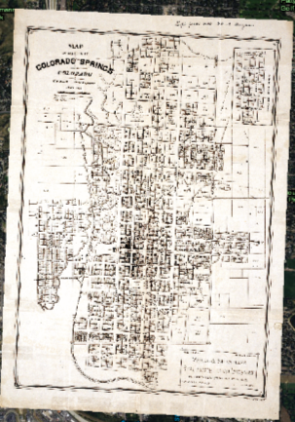 |  | GUIDING QUESTIONS  Skill: Purpose  - Who made this map?  - Why do you think this map was made?  - What are all the little black squares?  - Why are some of the numbered outlines empty?
cspmstoryofus.com
1907 Piles Peak Region
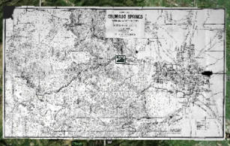 |  | GUIDING QUESTIONS  Skill: Legend  - How many Hotels are in Colorado Springs in 1907?  - How many Hospitals & Sanitariums are in Colorado Springs in 1907?  - How many miles wide is the map?  - How many miles tall is the map?
cspmstoryofus.com
1922 Pikes Peak Region
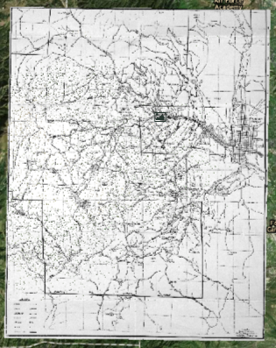 |  | GUIDING QUESTIONS  Skill: Comparative  - Can you find the Garden of the Gods? What do you notice about the area around it?  - Can you find Prospect Lake? What do you notice about the area around it?  - Can you find Interstate 25? Why not?
cspmstoryofus.com
1942 Voting Precincts
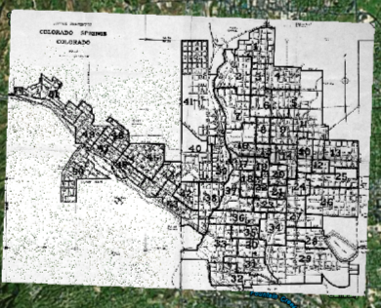 |  | GUIDING QUESTIONS  Skill: Title  - What is the title of this map?  - Why are their big numbers on the map?  - What do you noticed about where the darker lines are?  - Why do you think this map was made?
cspmstoryofus.com
1962 Colorado Springs
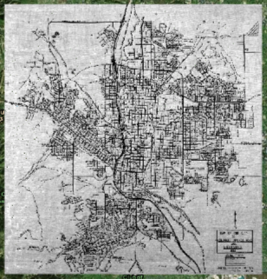 |  | GUIDING QUESTIONS  Skill: Legend  - How many creeks are there in Colorado Springs in 1962?  - Trace the city limits of Colorado Springs. What is not part of Colorado Springs in 1962?
cspmstoryofus.com
1980 Colorado Springs Streets
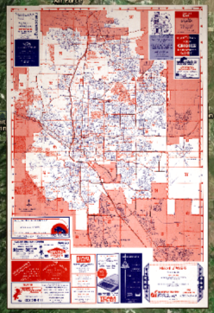 |  | GUIDING QUESTIONS  Skill: Navigation  - Find I-25. What areas of Colorado Springs did it run through in 1980?  - Find Academy. List five streets that cross Academy in 1980.  - Find Lake Ave. Where does Lake Ave dead end in 1980?  - Find Uintah Street. What direction does it run, north to south or east to west?
cspmstoryofus.com
Current Colorado Springs Street Map
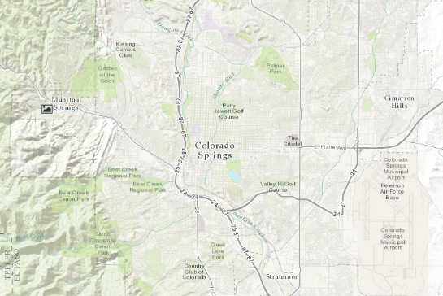 |  | GUIDING QUESTIONS  Skill: Interpretation and Inferencing  - What do the grey shapes represent?  - Why are the shapes mostly rectangular?  - What does the pink on the map stand for? How do you know?  - What does the blue on the map stand for? How do you know?  - What does the purple on the map stand for? How do you know?  - What does the bright green on the map stand for? How do you know?
cspmstoryofus.com
Assessment Question
How has Colorado Springs changed over time?
Colorado Springs has changed over time…(answers will vary)
Additional Resources
Additional information about reading maps may be found on the Arizona Geographic Alliance site, Interpreting Primary Sources with a Geographic Lens, https://geoalliance.asu.edu/geolens, as well from the National Archives, https://www.archives.gov/education/lessons/worksheets/map.html.
Please note: If you are planning a trip to the Pioneer’s Museum to have your students experience the SOU exhibit in person, please make sure to contact Meg Poole at the museum at least 2 weeks before your intended visit. This helps to ensure that someone is available to greet you and to help you navigate the museum. Contact info: mpoole@springsgov.com and/or 719-385-5631

